A REPORT ON
STRUCTURAL ANALYSIS AND DESIGN
ON RESIDENTIAL BUILDING
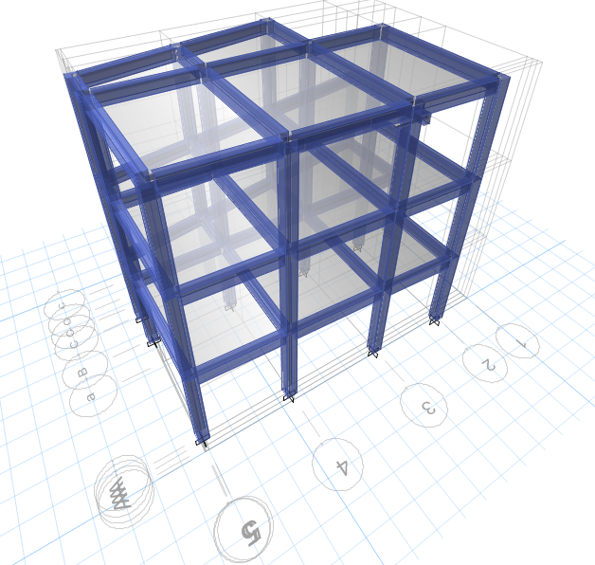
Location: Shankharapur NP-9
Owner: Mr. Biru Bipin Limbu
Date: 2080

CHAPTER 1: GENERAL DATA AND LOAD CALCULATION

Introduction
The basic aim of the structural design is to build a structure, which is safe, fulfilling the intended purpose during its estimated life span, economical in terms of initial and maintenance cost, durable and also maintaining a good aesthetic appearance. A building is considered to be structurally sound, if the individual elements and the building as a whole satisfy the criteria for strength, stability and serviceability and in seismic areas additional criteria for ductility and energy absorption capabilities. The overall building must be strong enough to transfer all loads through the structure to the ground without collapsing or losing structural integrity by rupture of the material at the critical sections, by transformation of the whole or parts into mechanisms or by instability. This strength criterion is valid for all loads that will normally be applied to the building during its lifetime. Accidents, overloading and disasters are not directly related to design. However, concern is needed for the structure to have structural integrity. A building needs to be designed for all loads acting on it. Detailed structural designs are carried out and working drawings are to be prepared. Safety is the prime concern of the structural design. Serviceability and economy are other basic requirements that are to be considered during structural design. The building should be designed not only for vertical loads, but also for horizontal loads such as wind and earthquake loads. A building and its structural elements must be strong enough to transfer all the loads acting on it safely to the ground. It should be able to withstand all loads acting on it.

Nepal lies in seismically vulnerable zone. It is located in the boundary of the two colliding tectonic plates- the Indian plate (Indo-Australian Plate) and the Tibetan plate (Eurasian Plate) which is known as “Subduction Zone”. Records of earthquakes are available in Nepal since 1255 A.D. Those records reveal that Nepal was hit by 18 major earthquakes since then, resulting in huge loss of life and property. Out of these earthquakes, the 1833 and 1934 earthquakes were the most destructive ones.

Designing building against earthquake forces does not mean that we are making the building proof against it. Although we can design such robust structure, it would be too expensive to build, it would be far cheaper to rebuild the building again instead of making it completely earthquake proof. The structures are generally designed for much lower seismic forces than what it may actually experience during its life time. Since the structure is expected to undergo damage in the event of a severe shaking, reliance is placed on the inelastic response of the structure beyond yield.

Therefore, structures have to be ductile and capable of dissipating energy through inelastic actions. Ductility can be achieved by avoiding brittle modes of failures. Brittle modes of failures include, shear and bond failure. Thus, structures should be designed on Weak Beam-Strong column philosophy.

The structural design alone is not enough to ensure the safety of the building, equally important, is its construction. The role of the contractor is of paramount importance as he is the one to execute the construction work at the site. He is required to execute the work according to the drawings supplied by the consultant to him and detailing has to be carefully followed. A large percentage of failure of the building is attributed to poor quality of construction. Past experiences from damages have shown that quality of material and workmanship plays an important role in good seismic behavior of the buildings. Hence, quality assurance in construction is expected to gain good seismic performance

Description of the Building

This is a two and half storied residential building which include a ground floor, first floor & top floor. The floor to floor height is 2.8448m. The building plan is rectangular in shape. The maximum height of the building is 9.906m. The width of the building is 7.519 m and length is 10.159 m.

Basic Data

General Features
Project | Residential Building
Location | Shankharapur Municipality-9, Kathmandu
Architectural features
Type of Building | Residential Building
Number of floors | 2.5 floors
Height of story | 2.8448m
Total Height of Building | 9.906 m
No. of Staircase | 1 no.
Height to width ratio | 1.317
Length to width ratio | 1.351
Wall and Partition | Brick Masonry walls
Structural Features
Structural system | RCC Frame Structure
Foundation Type | Isolated and Strap Footing
Column size | 305mm x 305mm
Beam Size | 230mm x 356mm
Slab | 125 mm Overall Depth
Geotechnical Features
Soil Type | Type II
Seismic Zone | V (as per IS 1893:2002)
Allowable Bearing Capacity | 120 KN/m³
Material
Grade of Concrete | M20 for column, beam, slab and footing
Grade of Steel | Fe500
Unit weight of Concrete | 20KN/m³
Unit weight of Masonry wall | 19 KN/m³
Young’s Modulus of Elasticity | $$5000\sqrt{fck}$$
Poisson’s Ratio | 0.2 for concrete
 | 0.3 for rebar

Relevant Codes followed

- IS 456-2000 : For Design of Structural Elements
- SP 16 : For Design Aid
- SP 34 : For Detailing
- IS 1893-2002: Criteria for Earthquake Resistant Design of Structures

Basic Principal of Analysis of the structure Step for earthquake load

1. Earthquake load with seismic coefficient method (IS 1893-2002)

Basic Principal of Design of Foundation

1. Isolated Footing to support the structure.

Software used for Analysis and Design

- ETABS 2016
- Custom Software

Concrete and Steel Grade

Concrete Grade = M 20 for Foundation,Columns, Beams and slabs
Steel Grade =Fe 500

Preliminary Design for proportioning of the Structural Elements

The tentative sizes of the Structural elements are determined through preliminary design so that after analysis, the presumed dimensions may not deviate considerably, thus making the final design both safe and economical. The tentative sizes have been determined as follows:

Slab: From Deflection Criteria [Effective Depth = Effective Shorter Span / (26 * MF)]

Beam: For Practical rule as 25mm Depth for 300mm of Span covering deflection criteria

Column: From evaluation of approximate gravity loading coming up to the critical Column.
To compensate for the possible eccentric Loading and earthquake loads the size is increased by about 25 % in design.

: 3DMODELLING, ANALYIS AND DESIGN

Modeling
The structural system is designed as a Special Moment Resisting Frame structure. Therefore, main components to be modeled are: Beams, Columns & Slabs. The analysis software used for modeling the structure is the ETABS 2016

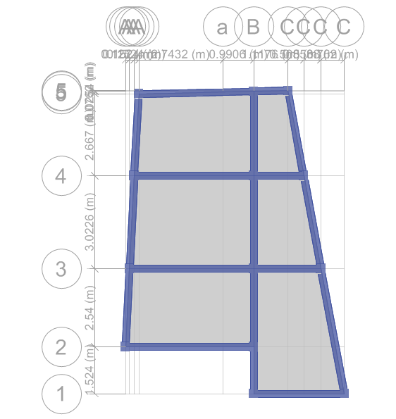

Fig: Plan view of building in ETABS 2016



Fig: 3D view of building in ETABS

Design Methods of Structural Elements

We have followed Indian Standard Code of Practice for Plain and Reinforced Concrete,
IS: 456 -2000 for design of Structural Elements. This incorporates the two methods of Structural Design of RC structures specified as:

- Working Stress Method based on the Working loads in conjunction with permissible stresses in the materials.
- Limit State Method based on safety and serviceability requirements associated with the design loads and design strengths of the materials. These design loads and design strengths are obtained by applying partial safety factors for characteristic loads and strengths of the materials concrete and steel.

We have followed the limit state method which is incorporated in IS: 456-2000. It is consistent with the new philosophy of design termed limit state approach which was incorporated in the Russian Code – 1954, the British code BS 8110 – 1985 and the American Code ACI 318 – 1989.

Limit State Method

- Limit States
The Limit State method of design covers the various forms of failure. There are several limit state at which the structure ceases to function, the most important among them being,

- The limit state of collapse or total failure of structure.
It corresponds to the maximum load carrying capacity. Violation of collapse implies failure. This limit state corresponds to Flexure, Compression, Shear and Torsion.

- The limit state of serviceability which includes excessive deflection and excessive local damage.

Analysis
The analysis has been carried out using a standard software package ETABSbased on finite element method. The software is capable of carrying out a Three Dimensional analysis. It is windows based software. It has a user friendly graphical input and output interface. It can account for the rigid zones at the beam - column junction. It has a capability to create a special joint at any grid intersection. The program has a facility to create shell elements also. Shell elements can be used for the analysis of Slabs and Shear walls. A full 3D finite element model using frame and shell elements can also be created using ETABS.
A Three Dimensional Linear elastic analysis has been carried out. Structure is assumed to be fixed at the Plinth level. The masonry wall load is distributed in the beams as uniformly distributed loads. The beams are modeled as rectangular beams. A model based on Rigid Diaphragm Concept has been considered. This is done by creating a special joint at the center of mass of each floor level and constraining all the joints at this level by a diaphragm constraint.

Load Cases
Following loads have been considered in the analysis of the building as per IS 456-2000 and IS1893:2002.

- Dead Load (DL)
- Live Load (LL)
- Earthquake Load in +ve X-direction (EQx)
- Earthquake Load in -ve X-direction (-EQx)
- Earthquake Load in +ve Y-direction (EQy)
- Earthquake Load in -ve Y-direction (-EQy)

Load Combination
Following load combinations have been adopted as per IS 1893:2002.
1.5(DL+LL)
1.2(DL+LL±EL)
1.5(DL±EL)
0.9DL±1.5EL where, DL = Dead Load
LL = Live Load
EL = Earthquake Load

Dead Loads
Dead loads are assumed to be produced by slab, beams, columns, walls, parapet walls, staircase, plasters and mortars, Floor finish and water tank. The weight of building materials are taken as per IS 875(Part 1)-1987).

Specific weight of materials [Ref: IS: 875(Part 1)-1987)]
Materials Unit weight
Reinforced Concrete 25 KN/m³
Brick Masonry 19 KN/m³
Floor Finishing (Screeding& Punning) 23 KN/m³
Cement Sand Plaster 20 KN/m³⁺
Floor Finishing (Marble) 26 KN/m³

Live Loads
Live loads are applied on floor slabs on the basis of usage of rooms, as specified in IS 875 part II.
Rooms 2 KN/m²
Toilet/Bathrooms/Kitchens 2 KN/m²
Balcony/Stairs 3 KN/m²
Terrace/Roof 1.5 KN/m²

Seismic Analysis

Design Base Shear V_{B} = Ah *W [7.5.3, IS: 1893 (part 1)-2002]
Where,
Ah = Design horizontal seismic coefficient as per 6.4.2 IS: 1893 (part 1)-2002]
= Z I Sa / (2 R g) = 0.09
Z =Zone Factor = 0.36 for seismic zone V
I = Importance Factor = 1.0
R = Response Reduction Factor = 5 for SMRF
Sa/g= Average Response acceleration coefficient on the basis of time period, T of the structure [Fig.2 IS: 1893 (part 1)-2002]
T = 0.075*h^{0.75}(7.6.2, IS: 1893 (part1)-2002]. For moment resisting frame
h=Height of building (m) above ground level [7.6.1 IS: 1893 (part1) 2002]
d= Base dimension of building at the plinth level in m, along the considered direction of lateral force.
W= Seismic Weight of Building, that includes total Dead load plus appropriate amount of live load. [7.4, IS: 1893 (part1)-2002].
• Percentage of live load to be taken for calculating seismic weight =25% for live load intensity upto and including 3.0 KN/m2 and 50% for live load intensity above 3.0 KN/m2. [Table 8, IS: 1893 (part1)-2002].
• The live load on roof need not be considered for calculating the seismic weight of the building. [7.3.2 IS: 1893 (part1)-2002].

Load Patterns
LoadPattern | DesignType | SelfWtMult | AutoLoad
DEAD | Dead | 1
LIVE | Live | 0
WALL | Dead | 0
FF | Dead | 0
EQX | Quake | 0 | IS1893 2002
EQY | Quake | 0 | IS1893 2002

Mass Source
MassSource | Elements | Masses | Loads | IsDefault | LoadPat | Multiplier
Text | Yes/No | Yes/No | Yes/No | Yes/No | Text | Unitless
MASS SOURCE | Yes | Yes | Yes | Yes | DEAD | 1
MASS SOURCE |  |  |  |  | LIVE | 0.25
MASS SOURCE |  |  |  |  | FF | 1
MASS SOURCE |  |  |  |  | WALL | 1

Design
The design of reinforced concrete structural members includes selection of material properties (grade of steel and concrete), shape and size of cross section, factor of safety and amount of steel required. The design of reinforced concrete members are carried out using limit state method as per IS 456: 2000. The limit state method is the modern and latest design methodology. This method evolved around 1970’s. Limit state method is based on the concept of multiple safety factors and attempts to provide adequate safety at the ultimate loads and adequate serviceability at service loads.
For the design of the members, IS 456:2000 and design aid SP 16 has been used. Footings have been checked for vertical loads and moments developed at the base due to dead load and live load only. Square footings have been adopted from seismic point of view that reversal stress may occur. And footing beams are provided for column at foundation for more rigidity of building and also need for the column located at boundary. Longitudinal reinforcement in beams and columns has been calculated based on critical load combination among the thirteen load combinations. Spacing of the shear reinforcement has been calculated as per the ductility criteria as defined in IS 13920 -1993. Some sample designs are shown later on in this report.

DesignParameters
Followings factors are considered for earthquake resistant design of the building.
BASE SHEAR CALCULATION SHEET
AS PER IS 1893
 |  |  |  | Remarks
Height of the building (m) |  |  | 9.906
Important factor |  |  | 1.00
Seismic Weight (W) |  |  | 3967.6546 | KN
Soil Type (II) |  |  | II | Medium Soil
Time Period in X direction (T) |  | 0.075*(H)^{3/4} | 0.4119
Average response acceleration coefficient (Sa/g ) |  |  | 2.500
Response reduction factor.R |  |  | 5.00
Seismic zone factor (Z) |  |  | 0.3600
Design horizontal seismic coefficient (A_{h}) |  |  | 0.0900
Design seismic base shear ( V_{B}) |  |  | 357.0889 | KN

Modal Result

Modal Periods and Frequencies
OutputCase | StepType | StepNum | Period | Frequency | CircFreq | Eigenvalue
Text | Text | Unitless | Sec | Cyc/sec | rad/sec | rad2/sec2
MODAL | Mode | 1 | 0.415 | 2.104 | 13.2171 | 174.6929
MODAL | Mode | 2 | 0.411 | 2.188 | 13.7454 | 188.937
MODAL | Mode | 3 | 0.39 | 2.561 | 16.0918 | 258.9446
MODAL | Mode | 4 | 0.167 | 5.998 | 37.6862 | 1420.2479
MODAL | Mode | 5 | 0.161 | 6.203 | 38.9765 | 1519.1647
MODAL | Mode | 6 | 0.144 | 6.958 | 43.7168 | 1911.1553
MODAL | Mode | 7 | 0.106 | 9.395 | 59.0311 | 3484.6723
MODAL | Mode | 8 | 0.105 | 9.513 | 59.7731 | 3572.8217
MODAL | Mode | 9 | 0.095 | 10.474 | 65.8075 | 4330.626
MODAL | Mode | 10 | 0.029 | 34.085 | 214.1632 | 45865.8719
MODAL | Mode | 11 | 0.022 | 45.253 | 284.3353 | 80846.5698
MODAL | Mode | 12 | 0.02 | 50.205 | 315.4498 | 99508.5838

Modal Participating Mass Ratios (Part 1 of 2)
OutputCase | StepNum | UX | UY | UZ | SumUX | SumUY | SumUZ
Text | Unitless | Unitless | Unitless | Unitless | Unitless | Unitless | Unitless
MODAL | Mode | 0.775 | 0.0626 | 0 | 0.775 | 0.0626 | 0
MODAL | Mode | 0.0812 | 0.7486 | 0 | 0.8563 | 0.8112 | 0
MODAL | Mode | 0.0104 | 0.0656 | 0 | 0.8667 | 0.8768 | 0
MODAL | Mode | 0.1019 | 0.0008 | 0 | 0.9685 | 0.8776 | 0
MODAL | Mode | 0.0016 | 0.0949 | 0 | 0.9702 | 0.9724 | 0
MODAL | Mode | 0.0036 | 0.0036 | 0 | 0.9737 | 0.976 | 0
MODAL | Mode | 0.0227 | 0.002 | 0 | 0.9964 | 0.9779 | 0
MODAL | Mode | 0.0028 | 0.0214 | 0 | 0.9992 | 0.9993 | 0
MODAL | Mode | 0.0008 | 0.0007 | 0 | 1 | 1 | 0
MODAL | Mode | 5.36E-06 | 0 | 0 | 1 | 1 | 0
MODAL | Mode | 0 | 0 | 0 | 1 | 1 | 0
MODAL | Mode | 6.61E-07 | 0 | 0 | 1 | 1 | 0

Modal Participating Mass Ratios (Part 2 of 2)
OutputCase | StepNum | RX | RY | RZ | SumRX | SumRY | SumRZ
Text | Unitless | Unitless | Unitless | Unitless | Unitless | Unitless | Unitless
MODAL | 1 | 0.0129 | 0.1635 | 0.0327 | 0.0129 | 0.1635 | 0.0327
MODAL | 2 | 0.1422 | 0.0119 | 0.0469 | 0.1551 | 0.1754 | 0.0796
MODAL | 3 | 0.0054 | 0.0008 | 0.7936 | 0.1605 | 0.1762 | 0.8733
MODAL | 4 | 0.0066 | 0.7102 | 0.0031 | 0.167 | 0.8864 | 0.8764
MODAL | 5 | 0.7458 | 0.0117 | 0.0027 | 0.9129 | 0.8981 | 0.879
MODAL | 6 | 0.0265 | 0.0299 | 0.0927 | 0.9393 | 0.928 | 0.9717
MODAL | 7 | 0.0046 | 0.065 | 0.0059 | 0.9439 | 0.993 | 0.9776
MODAL | 8 | 0.0535 | 0.0066 | 4.389E-05 | 0.9974 | 0.9996 | 0.9776
MODAL | 9 | 0.0026 | 0.0004 | 0.0224 | 1 | 1 | 1
MODAL | 10 | 2.934E-06 | 2.223E-05 | 8.721E-07 | 1 | 1 | 1
MODAL | 11 | 6.845E-07 | 7.481E-06 | 0 | 1 | 1 | 1
MODAL | 12 | 0 | 2.174E-06 | 0 | 1 | 1 | 1

Modal Load Participation Ratios

OutputCase | ItemType | Item | Static | Dynamic
Text | Text | Text | Percent | Percent
MODAL | Acceleration | UX | 100 | 100
MODAL | Acceleration | UY | 100 | 100
MODAL | Acceleration | UZ | 0 | 0

Modal Direction Factors
OutputCase | MODE | Period | UX | UY | UZ | RZ
Text | Unitless | Sec | KN-m | KN-m | KN-m | KN-m
MODAL | 1 | 0.415 | 0.903 | 0.073 | 0 | 0.024
MODAL | 2 | 0.411 | 0.091 | 0.86 | 0 | 0.05
MODAL | 3 | 0.39 | 0.014 | 0.071 | 0 | 0.915
MODAL | 4 | 0.167 | 0.944 | 0.009 | 0 | 0.048
MODAL | 5 | 0.161 | 0.015 | 0.96 | 0 | 0.024
MODAL | 6 | 0.144 | 0.04 | 0.037 | 0 | 0.923
MODAL | 7 | 0.106 | 0.826 | 0.094 | 0 | 0.081
MODAL | 8 | 0.105 | 0.112 | 0.886 | 0 | 0.002
MODAL | 9 | 0.095 | 0.105 | 0.028 | 0 | 0.868
MODAL | 10 | 0.029 | 0 | 0 | 0 | 1
MODAL | 11 | 0.022 | 0 | 0 | 0 | 1
MODAL | 12 | 0.02 | 0 | 0 | 0 | 1

Design of foundation
The purpose of the foundation is to effectively support the superstructure by transmitting the applied load effects to the soil below, without exceeding the safe bearing capacity of the superstructure by ensuring settlement of the structure is within tolerable limits, and as nearly uniform as possible.
The choice of the type of the foundation depends not only on the type of the superstructure and the magnitude and types of reactions induced at the base of the superstructure, but also on the nature of the soil strata on top of which the substructure is to be founded.
The foundation used for this building is isolated foundation. Bearing Capacity of Soil is 150KN/m2.

TABLE: JOINT REACTION
Joint | OutputCase | CaseType | F3
Text | Text | Text | KN
54 | DCON2 | Combination | 428.4
53 | DCON2 | Combination | 321.7
51 | DCON2 | Combination | 457.5
52 | DCON2 | Combination | 353.0
49 | DCON2 | Combination | 151.8
55 | DCON2 | Combination | 316.7
50 | DCON2 | Combination | 686.9
46 | DCON2 | Combination | 404.5
47 | DCON2 | Combination | 668.2
45 | DCON2 | Combination | 978.4
56 | DCON2 | Combination | 129.9
48 | DCON2 | Combination | 814.9
57 | DCON2 | Combination | 132.24

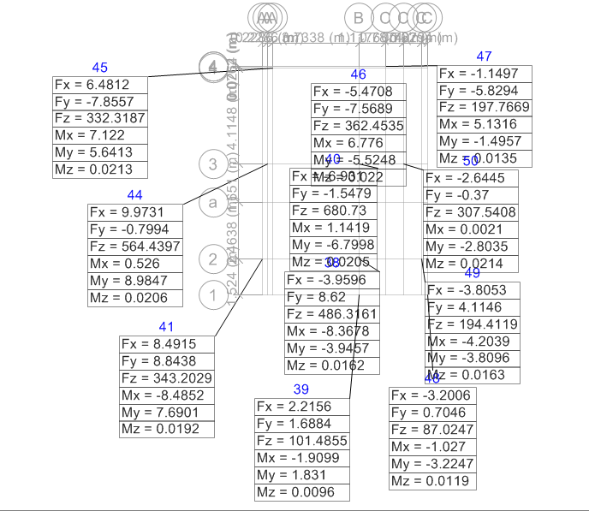

Showing Joint Reaction along respective joint:

DESIGN SUMMARY

1.Column Design Summary
SN | Column  Name | Column Size |  | Floor | Reinforcement |  |  | Lateral Ties
 |  | L (in) | B (in) |  | AR(mm²) | Bars | AP(mm²) | Dia./Leg | Side | Mid
1 | A2 | 12 | 12 | GF | 796 | 8$16 | 1609.00 | 8/4L | 4" c/c | 6" c/c
 |  |  |  | 1F | 743 | 4$16 +4$12 | 1256.64 | 8/4L | 4" c/c | 6" c/c
 |  |  |  | 2F | 743 | 4$16 +4$12 | 1256.64 | 8/4L | 4" c/c | 6" c/c
 |  |  |  | 3F
 |  |  |  | 4F
2 | A3 | 12 | 12 | GF | 762 | 8$16 | 1609.00 | 8/4L | 4" c/c | 6" c/c
 |  |  |  | 1F | 770 | 4$16 +4$12 | 1256.64 | 8/4L | 4" c/c | 6" c/c
 |  |  |  | 2F | 743 | 4$16 +4$12 | 1256.64 | 8/4L | 4" c/c | 6" c/c
 |  |  |  | 3F
 |  |  |  | 4F
3 | A4 | 12 | 12 | GF | 749 | 8$16 | 1609.00 | 8/4L | 4" c/c | 6" c/c
 |  |  |  | 1F | 752 | 4$16 +4$12 | 1256.64 | 8/4L | 4" c/c | 6" c/c
 |  |  |  | 2F | 743 | 4$16 +4$12 | 1256.64 | 8/4L | 4" c/c | 6" c/c
 |  |  |  | 3F
 |  |  |  | 4F
4 | A5 | 12 | 12 | GF | 788 | 8$16 | 1609.00 | 8/4L | 4" c/c | 6" c/c
 |  |  |  | 1F | 743 | 4$16 +4$12 | 1256.64 | 8/4L | 4" c/c | 6" c/c
 |  |  |  | 2F | 743 | 4$16 +4$12 | 1256.64 | 8/4L | 4" c/c | 6" c/c
 |  |  |  | 3F
 |  |  |  | 4F
5 | B1 | 12 | 12 | GF | 924 | 8$16 | 1609.00 | 8/4L | 4" c/c | 6" c/c
 |  |  |  | 1F | 743 | 4$16 +4$12 | 1256.64 | 8/4L | 4" c/c | 6" c/c
 |  |  |  | 2F
 |  |  |  | 3F
 |  |  |  | 4F

SN | Column  Name | Column Size |  | Floor | Reinforcement |  |  | Lateral Ties
 |  | L (in) | B (in) |  | AR(mm²) | Bars | AP(mm²) | Dia./Leg | Side | Mid
6 | B2 | 12 | 12 | GF | 790 | 8$16 | 1609.00 | 8/4L | 4" c/c | 6" c/c
 |  |  |  | 1F | 808 | 4$16 +4$12 | 1256.64 | 8/4L | 4" c/c | 6" c/c
 |  |  |  | 2F | 753 | 4$16 +4$12 | 1256.64 | 8/4L | 4" c/c | 6" c/c
 |  |  |  | 3F
 |  |  |  | 4F
7 | B3 | 12 | 12 | GF | 811 | 8$16 | 1609.00 | 8/4L | 4" c/c | 6" c/c
 |  |  |  | 1F | 912 | 4$16 +4$12 | 1256.64 | 8/4L | 4" c/c | 6" c/c
 |  |  |  | 2F | 781 | 4$16 +4$12 | 1256.64 | 8/4L | 4" c/c | 6" c/c
 |  |  |  | 3F
 |  |  |  | 4F
8 | B4 | 12 | 12 | GF | 980 | 8$16 | 1609.00 | 8/4L | 4" c/c | 6" c/c
 |  |  |  | 1F | 1119 | 4$16 +4$12 | 1256.64 | 8/4L | 4" c/c | 6" c/c
 |  |  |  | 2F | 752 | 4$16 +4$12 | 1256.64 | 8/4L | 4" c/c | 6" c/c
 |  |  |  | 3F
 |  |  |  | 4F
9 | B5 | 12 | 12 | GF | 1294 | 8$16 | 1609.00 | 8/4L | 4" c/c | 6" c/c
 |  |  |  | 1F | 1338 | 4$16 +4$12 | 1256.64 | 8/4L | 4" c/c | 6" c/c
 |  |  |  | 2F | 768 | 4$16 +4$12 | 1256.64 | 8/4L | 4" c/c | 6" c/c
 |  |  |  | 3F
 |  |  |  | 4F
10 | C1 | 12 | 12 | GF | 781 | 8$16 | 1609.00 | 8/4L | 4" c/c | 6" c/c
 |  |  |  | 1F | 835 | 4$16 +4$12 | 1256.64 | 8/4L | 4" c/c | 6" c/c
 |  |  |  | 2F
 |  |  |  | 3F
 |  |  |  | 4F
11 | C3 | 12 | 12 | GF | 836 | 8$16 | 1609.00 | 8/4L | 4" c/c | 6" c/c
 |  |  |  | 1F | 743 | 4$16 +4$12 | 1256.64 | 8/4L | 4" c/c | 6" c/c
 |  |  |  | 2F | 743 | 4$16 +4$12 | 1256.64 | 8/4L | 4" c/c | 6" c/c
 |  |  |  | 3F
 |  |  |  | 4F
12 | C4 | 12 | 12 | GF | 1098 | 8$16 | 1609.00 | 8/4L | 4" c/c | 6" c/c
 |  |  |  | 1F | 767 | 4$16 +4$12 | 1256.64 | 8/4L | 4" c/c | 6" c/c
 |  |  |  | 2F | 743 | 4$16 +4$12 | 1256.64 | 8/4L | 4" c/c | 6" c/c
 |  |  |  | 3F
 |  |  |  | 4F
13 | C5 | 12 | 12 | GF | 1341 | 8$16 | 1609.00 | 8/4L | 4" c/c | 6" c/c
 |  |  |  | 1F | 793 | 4$16 +4$12 | 1256.64 | 8/4L | 4" c/c | 6" c/c
 |  |  |  | 2F | 743 | 4$16 +4$12 | 1256.64 | 8/4L | 4" c/c | 6" c/c
 |  |  |  | 3F
 |  |  |  | 4F

2.Beam Design Summary

 | Design parameters:
 | Concrete Grade: |  |  | M20
 | Steel Grade: |  |  | Fe500
 | Clear Cover: |  |  | 25mm
Beam Reinforcement Detail
Floor |  | Size | Main Reinforcement Through |  |  |  | Extra Reinforcement Ends |  |  | Stirrup
 |  |  | Top |  | Bottom |  | Top |  | Bottom | End |  | Middle
PlinthTie |  | 9"x9" | 3-12φ |  | 3-12φ |  |  |  |  | 8φ4"c-c |  | 8φ6"c-c
Ground Floor |  | 9"x14" | 2-16φ+1-12 φ |  | 2-16φ |  |  |  |  | 8φ4"c-c |  | 8φ4"c-c
1st Floor |  | 9"x14" | 2-16φ+1-12 φ |  | 2-16φ |  | 1-16φ |  |  | 8φ4"c-c |  | 8φ4"c-c
2nd Floor |  | 9"x14" | 2-16φ |  | 2-16φ |  | 1-12φ |  |  | 8φ4"c-c |  | 8φ4"c-c

3.Design of two way slab :
Slab Design for panel S-AB34
Input Parameters
Length of shorter span (lx) = |  |  |  | 3.02 | m
Length of longer span (ly) = |  |  |  | 4.17 | m
    Support condition |  |  |  | 3
Slab type
 |  |  | α = | 26
 |  |  | β = | 1
γ (assumed) = |  |  |  | 1.4
ly/lx = |  |  |  | 1.38
Design two way slab
Assume grade of concrete (fck) = |  |  |  | M | 20
Assume steel (fy) = |  |  |  | Fe | 500
Thickness of finishing = |  |  |  | 3.00 | mm
Thickness of screed = |  |  |  | 40.00 | mm
Thickness of plaster = |  |  |  | 12.50 | mm
Unit weight of finishing = |  |  |  | 21.00 | KN/m³
Unit weight of screed = |  |  |  | 23.00 | KN/m³
Unit weight of plaster = |  |  |  | 20.40 | KN/m³
Unit weight of concrete = |  |  |  | 25.00 | KN/m³
Live load = |  |  |  | 2 | KN/m²
Assume bar diameter = |  |  |  | 8.00 | mm
Effective depth of slab (d)  |  |  |  | 83.07 | mm
Assume, d = |  |  |  | 125.00 | mm
Total depth of slab, D = |  |  |  | 149.00 | mm
Dead load calculation of slab
Dead load of slab due to concrete = |  |  |  | 3.73 | KN/m²
Dead load due to floor finish Tile = |  |  |  | 0.06 | KN/m²
Dead load due to screed = |  |  |  | 0.92 | KN/m²
Dead load due to plaster = |  |  |  | 0.26 | KN/m²
Partition load = |  |  |  | 1.40 | KN/m²
Total dead load = |  |  |  | 6.36 | KN/m²
Dead load + Live load = |  |  |  | 8.36 | KN/m²
Design load = |  |  |  | 12.54 | KN/m²
Bending moment Coefficients |  |  | Max. bending moment
α_{x} = | 0.0463 |  | M_{x} = | 5.31 | KNm
−α_{x} = | 0.0617 |  | -M_{x} = | 7.07 | KNm
α_{y} = | 0.0280 |  | M_{y} = | 6.10 | KNm
−α_{y} = | 0.0370 |  | -M_{y} = | 8.06 | KNm
 |  |  | M_{max} = | 8.06 | KNm
Check depth for moment
Required depth for moment = |  |  |  | 54.03 | mm
Provided depth, d = |  |  |  | 125.00 | mm
Required depth is |  | < | Provided depth
O.K. safe
Area of steel
Solving quadratic equation
0.025 | Ast² + | -125.00 | Ast + | 14018.10 | = 0
0.025 | Ast² + | -125.00 | Ast + | 18523.91 | = 0
Bottom bars |  |  | Top bars
Ast = | 4885.22 | mm² | Ast = | 4847.14 | mm²
Ast = | 114.78 | mm² | Ast = | 152.86 | mm²
Spacing required
8 | φ rods @ | 437.7 | mm c/c | Bottom bars
8 | φ rods @ | 328.66 | mm c/c | Top bars
Spacing provided
8 | φ rods @ | 150.0 | mm c/c | Bottom bars
8 | φ rods @ | 150.0 | mm c/c | Top bars
Check for shear
Provided Ast = |  | 334.93 | mm²
p% = |  | 0.27 | k = | 1.3
 | τ_{c}' = | 0.37 | N/mm² | IS 456:2000 (Table 19)
 | τ_{c} = | 0.48 | N/mm²
Max.shear force (V_{u}) = |  | 18.96 | KN
 | τ_{v} = | 0.15 | N/mm²
 | τ_{c} | > | τ_{v}
 |  | O.K. safe
Check for minimum steel
Minimum steel (0.12%) |  |  | Provided steel
150.00 | mm² | < | 334.93 | mm²
 | O.K.
Check for deflection
α = | 26 | f_{s} = | 99.381 | λ = | 1
β = | 1 | γ = | 2.000 | δ = | 1
Allowable L/d = |  | 52.00
Actual L/d = |  | 24.19
Allowable L/d |  | > | Actual L/d
 | O.K.

3.Design of Isolated Footing :
Design of Isolated foundation for column Node no:46
Axial Load on Column, P = |  |  |  | 269.67 | kN
Bearing Capacity of soil q= |  |  |  | 150 | kN/sq.m
length of column= |  |  |  | 350 | mm
Breadth of Column= |  |  |  | 350 | mm
 |  |  | fck= | 20 | N/sq.mm
 |  |  | fy= | 500 | N/sq.mm
Calculation of Load
 |  | P= | 179.7778 | kN
 |  | Self wt. of footing= |  | 10% of Axial load on column
 |  |  |  | 17.97778 | kN
 |  | Total Load = |  | 197.7556 | kN
Area of footing
 |  | A= | Total Load/Bearing Capacity of Soil
 |  | = | 1.31837 | Sq.m
Therefore , Size of Footing= |  |  |  | 1.15 | m
Considering
Length of Footing= |  |  |  | 1.8288 | m
Breadth of Footing= |  |  |  | 1.8288 | m
Effective Width be= |  |  | b+(B-b)/8
 |  | = | 491.10 | mm
 |  | ~ | 550 | mm
Uplift Pressure, P=
 |  | = | 80.62966 | kN/sq.m
Moment at Col. Face= |  |  |  | 43.07967 | kNm
 |  | dmin= | √(M/1.38*fck*be)
 |  | = | 176.6838 | mm
 |  | ~ | 430 | mm
 |  | Adopt D | 600 | mm
Area of Reinforcement
 |  | M= | 0.87*fy*Ast*(d-(fy*Ast/fck*be)
Solving it into quadratic equation
A=fy |  | 500
B=bdfck |  | 11795760
C=BM*fck*b/(.87*fy) |  |  | 2.72E+09
Ast=(-b+SQRT(b^2-4*A*C))/(2*A) |  |  |  | 232.6044
 |  | Therefore, Ast=1437.1 sq.mm
Providing 12mm dia reinforcement, Asteel=113 sq.mm
 |  |  | Spacing= | (B)/Ast/Asteel
 |  |  | = | 888.4371 | mm
 |  |  | Consider Spacing= 150mm |  | 150 | mm
 |  |  |  | Ast provided= | 1921.0 | sqmm | sq.mm
 |  | % of reinforcement = (Ast provided/B*D)*100
 |  |  | = | 0.244283 | %
Provide 12mm dia reinforcement on both side @150mm c/c

Design of Combined Footing

Axial load on Column B4= |  |  | 445.5 | kN | c/c dist. | 1.9 | Column 1
Axial load on Column C4= |  |  | 652.2 | kN | left edge | 0.2
Size of Column B3= |  |  | 305 | mm | edge to c/c dist | 2.1
Size of Column C3= |  |  | 305 | mm
Bearing Capacity of soil= |  |  | 150 | kN/sq.m |  |  | Column 7
 |  |  |  |  | Right edge | 0.15
Taking node 1&7
i.Length and Width of the footing
Centre of gravity of load from the property line
 | X= | (PA*x+PB*y)/(PA+PB)
 |  | 1.33 | m
Length of Footing= |  | 2*X
 |  | 2.6636751 | m
 | Assume | 2.8 | m
Assume Weight of footing and earth above it as 5% of total weight
 | Total load on earth= |  | (PA+PB)*1.05
 |  |  | 1152.55 | kN
 | Footing Width= |  | Total Load on earth/(length of footing*Bearing Capacity)
 |  |  | 2.744167 | m
 | Adopt | 1.5 | m width of footing
ii.Longitudinal Bending moment and shear
 | Factored load on Column B1= |  |  | 668.2 | kN
 | Factored load on Column C1= |  |  | 978.3 | kN
 | Net upward Soil Pressure= |  |  | (Pau+Pbu)/(length of footing*width of Footing)
 |  |  |  | 392.0238 | kN/sq.m
 | Net upward soil pressure per unit length= |  |  |  | 588.04 | kN/m
 | Maximum shear force at centre line of column A
 |  |  | V1= | Netupward soil pressure per unit length * c/c distance
 |  | Negative shear force |  | -117.607 | kN
 |  |  | V2= | V1+Pau
 |  | Positive shear force |  | 550.5929 | kN
 | Maximum Shear force at centre line of Column B
 |  |  | V1= | Netupward soil pressure per unit length * c/c distance
 |  | Negative shear force |  | -890.095 | kN
 |  |  | V2= | V1-Pbu
 |  | Positive shear force |  | 88.20536 | kN
 | Point of Zero Shear force from centre of column A(from Calculation)
 |  | x= | 0.728005
 | Maximum bending moment computed from left side
BM= | (Net upward soil pressure (dist. From left edgt to A column+X)^2)/2-1.5*Factored load*X
 |  | -233.2468 | KNm
 | Maximum bending moment computed from Right side
BM= | (Net upward soil pressure (dist. From right edgt to B column+X)^2)/2-1.5*Factored load B*X
 |  | -485.5512 | KNm
 | For computation thickness of footing
 | Bm= | 0.138*fck*b*d^2
 | d^2= | 56339.802
 | d= | 237.36007 | mm
 |  | 350 | mm
 | Adopt overall depth as 450mm & effective depth as 410mm
iii) Main negative longitudinal reinforcement
 | BM= | 0.87*fy*Ast (d-fy*ast/(fck*b))
 | Simplyfying this into Quadratic equation (Ax^2+Bx+c=0)
 | Ast= | 1719.79 | sqm
 | use 12mm dia bar which gives 113 sqmm
 | No of bars= | 15.22 | 18 | nos
 | Spacing | 166.67
 | Adopt 150mm spacing using 12mm dia bar
 |  |  |  | Development length for bar=56 dia

4.1Footing Design:

The output of the design of footing is presented below. The construction shall follow the detail
drawing of footing.

Node No. | Footing | Footing Size | Rebar | Thickness
50, 51, 53 | F1 | 5’0”X5’0” | Φ12@ 150mm c/c both direction | 1’-10”
49, 46 | F2 | 6’0”X6’0” | Φ12@ 150mm c/c both direction | 1’-10”
48 & 57, 47 & 45, 55 & 50, and 52 & 54 | CF | 8’0”X6’0” | Φ12@ 150mm c/c both direction | 1’-10”

5.Design of Staircase
Y = | 25 | N/m3
Effective Span | 3.3 | m
Riser (R) | 178 | mm
Tread (T) | 254 | mm
√ (R²+T²) | 310.16 | mm
Assume waist slab thickness (d) | 100 | mm
(D) | 125 | mm
Assumed grade of concrete (fck) | M20
Assumed steel (fy) | Fe 500
Loads on stairs
Self weight of waist slab | 3  82 | KN/m2
Self weight o  steps | 2.225 | KN/ m²
Finish | 1 | KN/m²
Live Load | 3 | KN/m²
Total Load | 10.04 | KN/m²
Loads on landing
Self weight of slab | 3.125 | KN/m²
Finish | 1 | KN/m²
Live Load | 3 | KN/m²
Total Load | 7.125 | KN/m²
Design Moment considering 1 m wide strip fo waist slab.
Reactions
R_{A} = | 18.09 | KN
R_{B} = | 12.92 | KN
Max moment at x= | 1.580 | m from A support
BMmax | 11.70 | KNm/m
Depth required
M=2.66bd^2 (for M20 and Fe500)
d | 66.32 | mm
d (provided) | 120 | mm (OK)
Ast required
BM= 0.87fyAst (d-(Ast*fy)/(fck*b))
Ast | 235.71 | mm2
φ = | 12 | mm
spacing | 480.00 | mm
Distributors
= 0.12% of b D | 150 | mm2
φ = | 8 | mm
spacing | 335.24 | mm
Shear check
Max shear at distance d from the support
V_{u} = | 17.87 | KN
Τ_{v} = V_{u}/b d | 0.179 | N/mm
Τ_{c}
% = 100 * (Ast/b d) | 0.235713066 | %
Τ_{c} = | 0.44 | for M 20
k = | 1.3
k Τ_{c} = | 0.57 | N/mm2>Τv (OK)
Provide 12 mm φ @ 150 mm spacing c/c | Main bars
Provide 10 mm φ @ 150 mm spacing c/c | Distribution bars

: ANNEXES, CONCULSION AND REFRENCES

Annexes

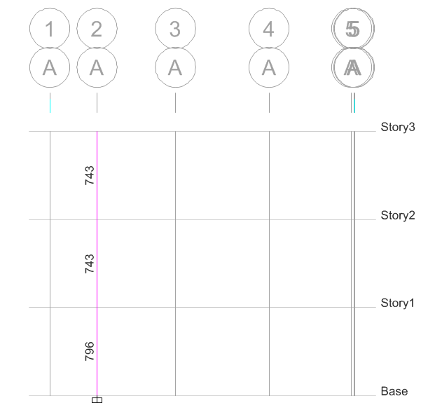

Column reinforcement along grid A-A (mm2)
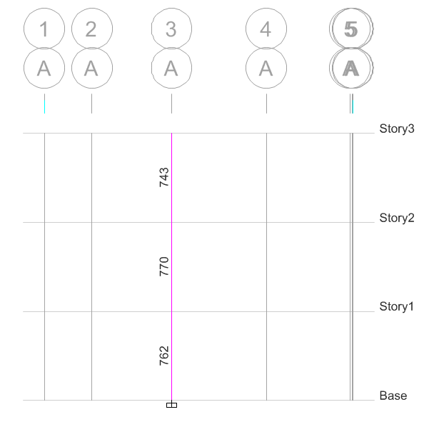

Column reinforcement along grid A-A (mm2)

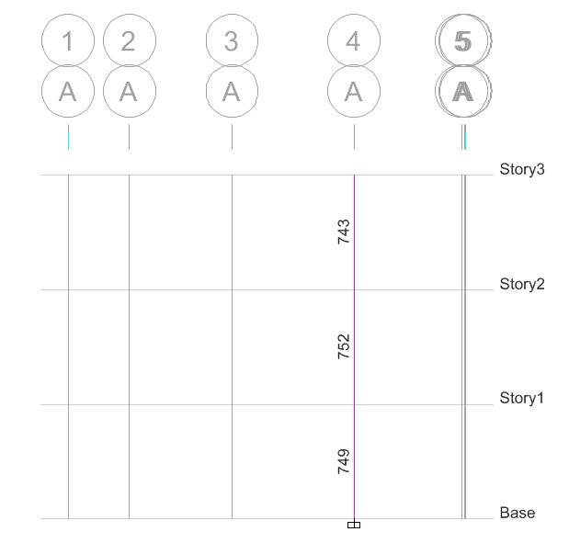

Column reinforcement along grid A-A (mm2)
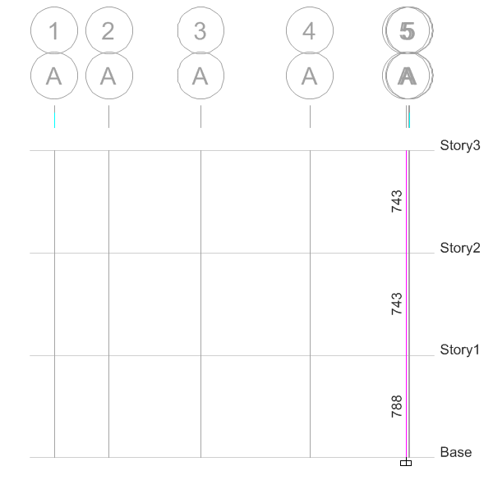

Column reinforcement along grid A-A (mm2)

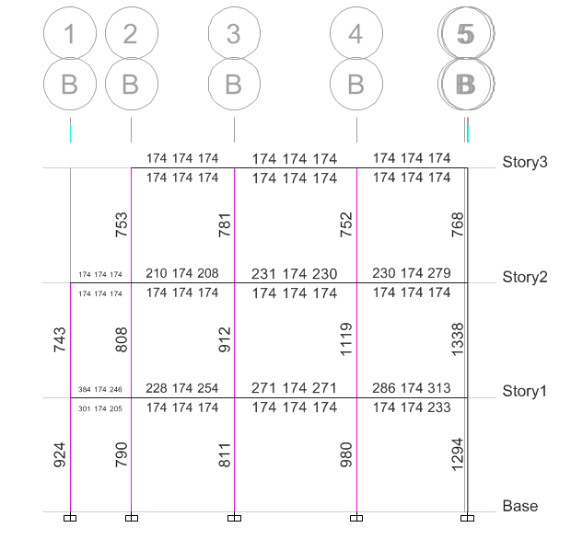

Column reinforcement along grid B-B (mm2)

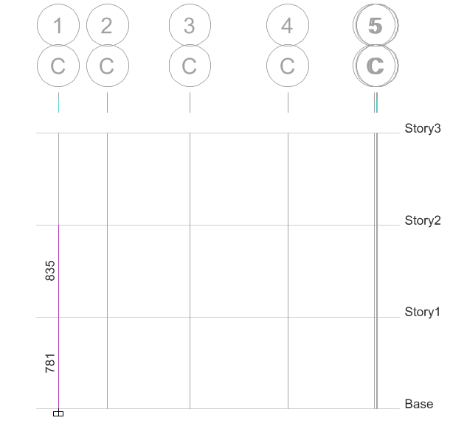

Column reinforcement along grid C-C (mm2)

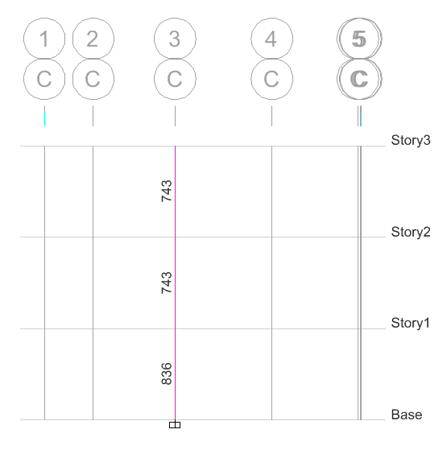

Column reinforcement along grid C-C (mm2)

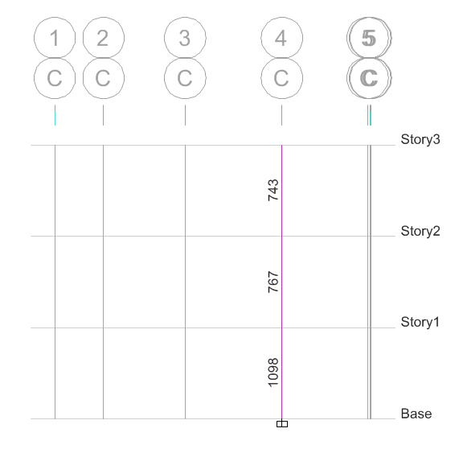

Column reinforcement along grid C-C (mm2)
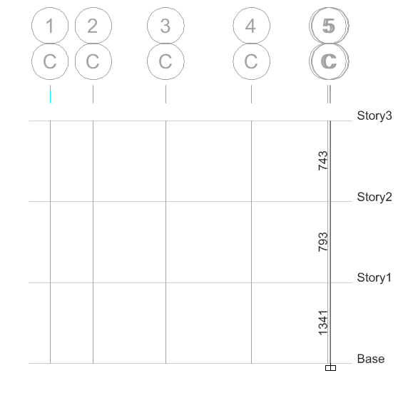

Column reinforcement along grid C-C (mm2)

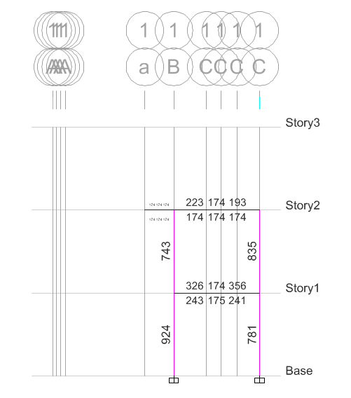

Column reinforcement along grid 1-1(mm2)

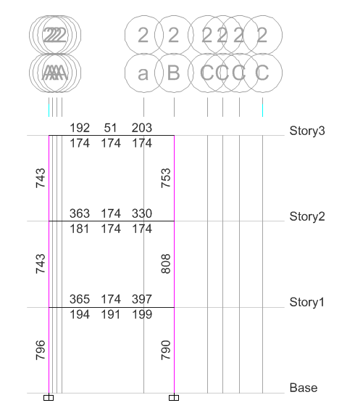

Column reinforcement along grid 2-2 (mm2)

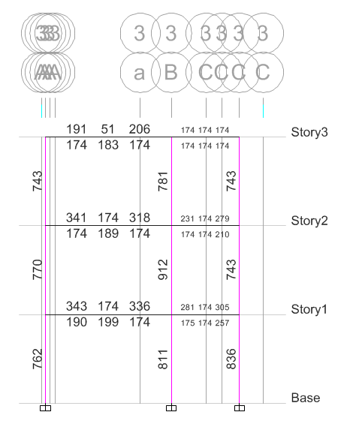

Column reinforcement along grid 3-3 (mm2)

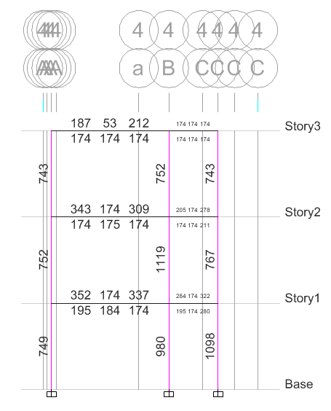

Column reinforcement along grid 4-4 (mm2)
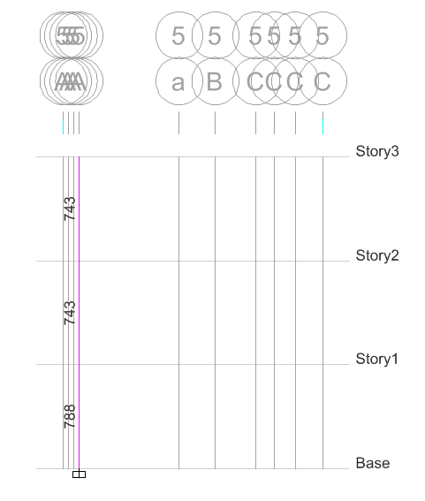

Column reinforcement along grid 5-5 (mm2)

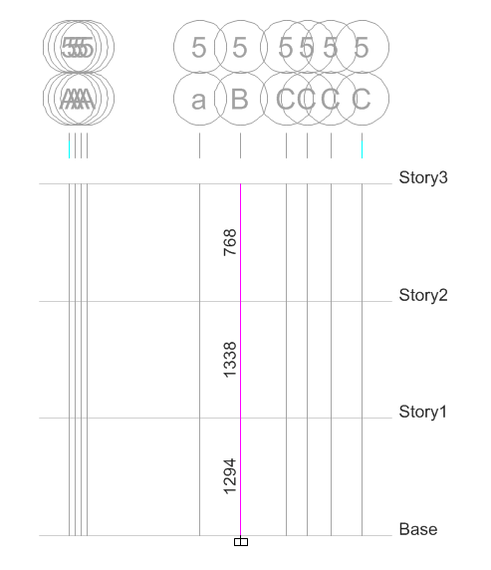

Column reinforcement along grid 5-5 (mm2)

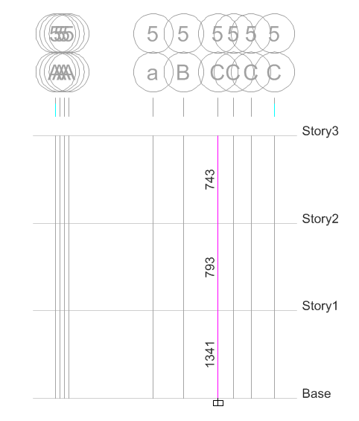

Column reinforcement along grid 5-5 (mm2)

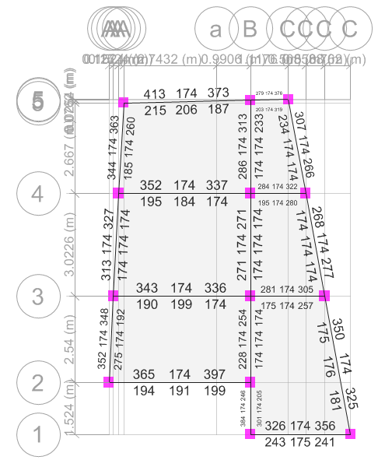

Beam reinforcement along first storey(mm2)

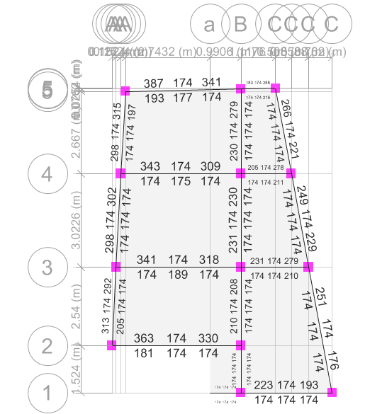

Beam reinforcement along second storey(mm2)

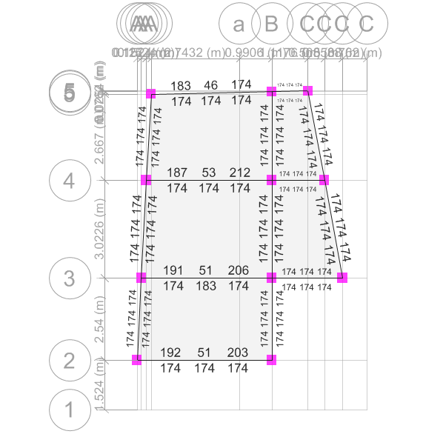

Beam reinforcement along top storey(mm2)

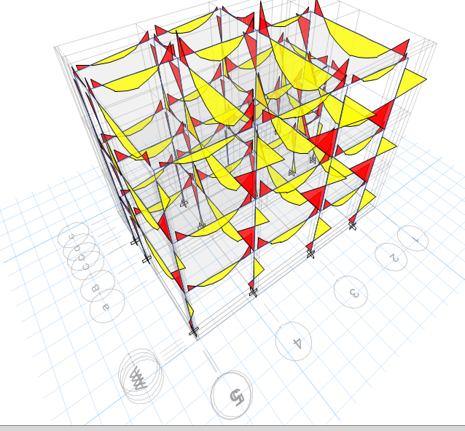

Moment diagram

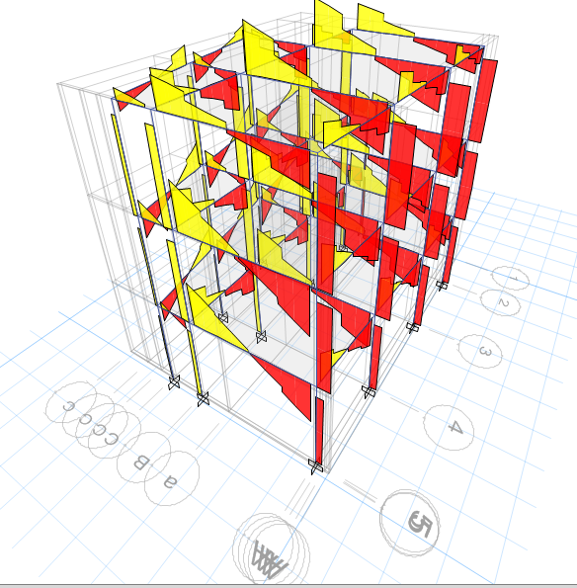
Shear force diagram

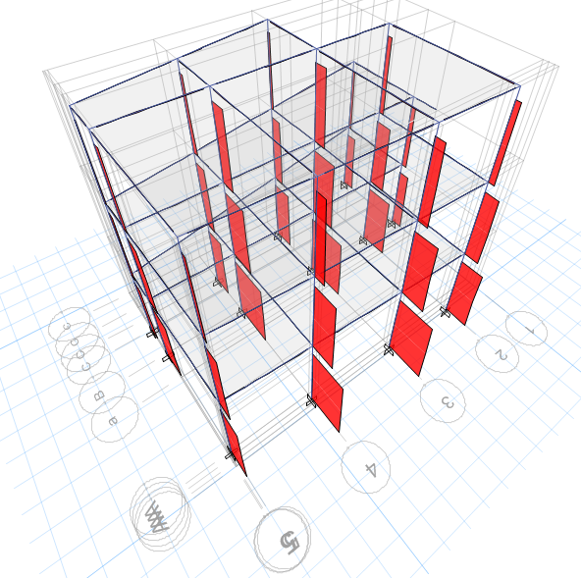

Axial force diagram

Conclusion

Ductility and strength required to resist major earthquake can be achieved by following the recommendations made in the standard codes of practice for earthquake resistant design. After the analysis of the building components, the building is found to be safe against the loads considered above. All the sections are found to be stressed within the permissible limits due to axial, shear, flexural and torsional forces produced due to above forces. The slab and foundations were checked manually. Shear stirrups is sufficiently provided so that none of the elements are Vulnerable to shear failure and failure mode will be flexural, which is more ductile. Bearing capacity of the soil is assumed to be 150 KN/m2. It is strongly recommended to check the bearing capacity before construction so as to ensure the assumed value is within safe limits. The structural safety would further depend upon the effectiveness of construction procedures as well as collapse and serviceability criteria followed during the construction phases.
Design and construction of the structure are inter – related jobs. A building behaves in a manner how it has been built rather than what the intensions is during designing. A large percentage of structural failures are attributed due to poor quality of construction. Therefore, quality assurance is needed in both design and construction. Durable M20 concrete has been used in the foundation which is in contact with the soil. M20 grade of concrete is used during analysis and design for Beams and slabs whereas M25 grade is used during analysis and design for columns. Ductile detailing has been extensively adopted while detailing.

References

IS: 456 – 2000 Code of Practice for Plain and Reinforced Concrete

IS: 875 (Parts 1-5) Code of practice for design loads (other than earthquake) for buildings and structures (second revision) Part 1 – Dead loads Part 2 – Imposed loads

NBC 105: 1994 Seismic Design of Buildings in Nepal

IS: 1893 – 2002 Criteria for Earthquake Resistant Design of Structures

IS: 13920 - 1993 Ductile Detailing of Reinforced Concrete Structures subjected to Seismic forces - Code of Practice

SP: 16 – 1980 Design Aids for Reinforced Concrete to IS: 456 – 1978

SP: 34 – 1987

Jain, A.K.

Handbook on Concrete Reinforcement Detailing

Reinforced Concrete, Limit State Design, fifth edition, Nem Chand and Bros, Rookie, 1999
Sinha, S. N.

Pillai,U.C. and Menon,D.

Reinforced Concrete Design, Second edition, Tata McGraw Hill Publishing Company Ltd, New Delhi, 1996

Reinforced Concrete Design, Second edition, Tata McGraw Hill Publishing Company Ltd, New Delhi, 2003

